**Poker game**

**(Product Backlog)**

**https://github.com/srhee91/PokerGame**

Team 3

So Mi Choi, Bo Heon Jeong, Hanchen Li, Sang Rhee, Yixin Wang, Yuying Wang

**Product Backlog**

Problem Statement:

People need to have fun gambling without losing actual money online. An interactive Texas Hold’em game can be created to satisfy this need.

Background:

Most poker games that exist currently are played over the web between total strangers. We aim to offer a casual poker game that you and your friends can play or spectate on their laptops/desktops connected over a local network. New users can jump right in without providing credentials or real money. Our targeted users are those who want to enjoy a game of poker together, but don’t have physical playing cards or chips. While there are a lot of existing poker applications out there (such as Zynga Poker), most are focused on playing with strangers far away. Our game hopes to make a “LAN party” atmosphere possible for poker. A slight variation on our proposed solution would be a poker game running on a single system being shared by all players (in other words, passing a laptop around), but we believe having 8 players share one system is too inconvenient.

System model:

1. Diagram

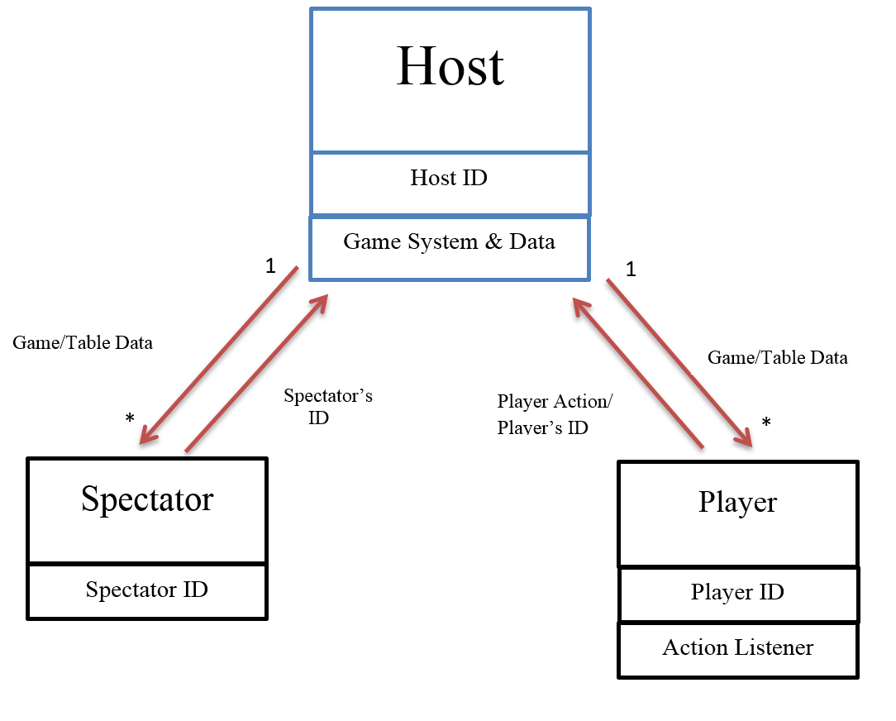

1. Interactions
   1. When the game is being played
      1. Host sends “game data” to Player
      2. Player sends “player action” to Host
      3. Host sends “game data” to Spectator
   2. Before the game is started
      1. Player sends “Player’s ID” to Host
      2. Host sends “table info” to Player
      3. Spectator sends “Spectator’s ID” to Host
      4. Host sends “table info” to Spectator

Requirements:

* Must be done
* Functional
  + The game can be in the following modes:
    - “Startup”: this is the state of the program when it’s first started. It can also be entered if the player leaves his/her game, either from the game ending or the player quitting. In this mode, the user can enter a player name and then choose from three options, each having an onscreen button: creating (hosting) a game, joining an existing game, or spectating an ongoing game. All three options require the user to enter a port number on which the game is/will be hosted. The program leaves this mode when the player chooses any of those options.
    - “Lobby”: the program enters this state when a player chooses to create a game or join a game in the “startup” state. This mode will display names of new players as they join. The game host will be provided an onscreen button to start the game when at least one other player has joined, while other players in the lobby must wait for the host to start the game. When the host starts the game, all players will go on the “ongoing” mode.
    - “Ongoing”: this mode is where the actual poker game takes place. Each player will have their own space onscreen that displays their name, their cards (face up or face down, depending on the situation), their chip amount, and their action during this turn. The center of the screen will show the flop, turn, and river, as well as the chip amount in the pot. Players will be prompted for an action when it’s their turn through onscreen buttons (fold, check/call, raise/all in). The state of the poker game is updated in accordance with the rules of Texas Hold’em. This mode continues until only one player has chips remaining. The program will then enter the “over” state.
    - “Over”: this mode is entered when an ongoing game ends, which occurs when only one player has money remaining. It will display the winner’s name as well as some game stats. The user can then push an onscreen button to return to the “startup” state.
  + The user can only join a game when it’s still in “lobby” mode. Once the host starts the game, new players may not join. Any attempt to join an ongoing or nonexistent game will result in an error message displayed on the “startup” screen.
  + The user player can spectate a game only after it has started. In other words, the game must be in the “ongoing” state. Any attempt to join a game in “lobby” mode or a nonexistent game will result in an error message displayed on the “startup” screen.
  + The user may quit any game during the “ongoing” state as a player or spectator by clicking an onscreen button. If the user was a player in the game, his/her money simply disappears from the game. The program will return to the “startup” state for that user.
  + In the “ongoing” mode, anytime a new action occurs (e.g. a player folds, the dealer changes, the flop being revealed, etc.), the GUI of every player or spectator in the game will update in real time to reflect that action.
  + In the “ongoing” mode, each player will have 30 seconds to make their decision (fold, check/call, raise/all in) before folding by default. The time remaining will be displayed on the GUI of that player during his/her turn. The actions available to the player during his/her turn will be in accordance with Texas Hold’em rules.
  + In the “ongoing” mode, animations accompanied by sounds will occur when actions are taken. Cards will move across the screen when being dealt or if a player folds. A chip image with a dollar amount will move between a player and the pot to signify betting or a player winning the pot. Cards will flip over realistically when a showdown occurs.
* Non-functional
  + The game will be programmed in Java. The Slick2D library will be used for rendering the game screen.
  + The game will run at a minimum 60 frames per second at all times on any system that’s at least as powerful as a modern entry-level laptop.
  + If the game state for a player or spectator gets out of sync with what the host has stored, it will be corrected for that player the next time the game state changes (assuming the error responsible was temporary and did not permanently disconnect that player from the host).
  + If a player’s system crashes for some reason, the game host will detect this and remove that player from the game, as if he/she had willingly quit.
  + If a host’s system crashes for some reason, a game in the “lobby” or “ongoing” state will immediately revert back to the “startup” state for all other players and spectators, gracefully ending the game.
  + Any onscreen buttons that represents a definite invalid action in the game’s current state will be grayed out to convey this to the user.
* Will be done if time allows
* Functional
  + When the system is in “lobby” state, the user can choose among multiple existing games that are listed on the screen (instead of having to provide a port number), and click the “Join” or “Spectate” button to join in.
  + While users are in “lobby” or “ongoing” state, they will be able to chat with the other players in a chat box. The chat box will display the name of the player who sent the message and the content of message. Players can also choose from a selection of premade messages to send out.
* Non-functional
  + Players will be reconnected to the host immediately if their connection to the host is temporarily lost.
  + Host migration: if the host leaves a game in the “lobby” or “ongoing” state, another player will automatically be chosen to become the new host, and the game will continue from its last game state.